**Power BI Dashboard: Students Performance in Exams**

In this project, I use Power BI to analyze students’ exam performance across metrics like math, reading, and writing scores. By applying advanced DAX measures and insightful visuals, I uncover how demographic factors such as parental education, gender, and test preparation impact academic outcomes.

**Goal:** The goal is to develop advanced DAX calculations that work with interactive visuals to show how parental education level and gender and race/ethnicity impact test scores alongside test preparation methods in mathematical reading and writing examination sections*.***Technology:** Power BI, DAX, Power Query, Excel  
**Skills:** Dashboard Development, KPI Definition, Effective Data Visualization, Interactive Reporting  
Explore the Complete Project here →

# **Power BI dashboard: Students Performance in Exams**

**Math Score by Parental Education Level**  
I created a bar chart showing the sum of math scores grouped by parental education level. I used Power BI’s default aggregation function (*Sum*) without DAX to display how parental education relates to total math scores. This chart illustrates how total scores in math, writing, reading, and test preparation participation vary as parental education changes, revealing a negative relationship between parental education attainment and total scores.

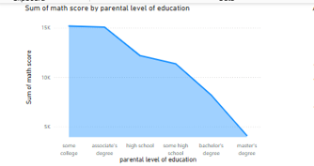

**Math Score by Test Preparation Course and Gender**  
I created a clustered bar chart showing the average math scores based on test preparation course status and gender. I used Power BI’s default *Average* aggregation function to calculate math scores for students who completed or did not complete the preparation course, separated by male and female categories. The test preparation course delivers greater average math scores to students, and boys outperform females in assessment results.

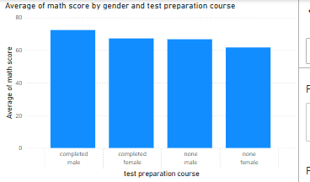

**Average Math Score by Race/Ethnicity**  
I built a column chart displaying the average math scores for each race/ethnicity group. I applied Power BI’s Average aggregation directly from the visual fields pane to show differences in math performance across groups. The average math score by race/ethnicity demonstrates that Group A obtains the highest math achievement scores, while other race/ethnicity groups exhibit lower results.

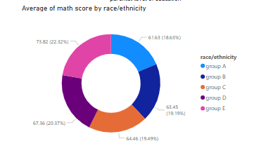

**Writing Score by Race/Ethnicity and Gender**  
I created a matrix visual showing average writing scores by race/ethnicity and gender. I used Power BI’s standard Average aggregation without DAX, letting the matrix visual highlight gender differences in writing scores. The data demonstrates that writing scores between races and genders show female students scoring higher than male students throughout most ethnicity groups.  
This chart illustrates how average writing scores vary by race/ethnicity and gender, consistently showing that females outperform males across most ethnicity groups.

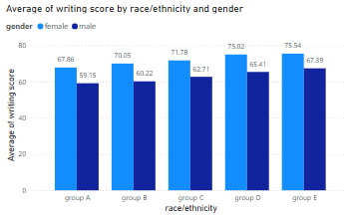

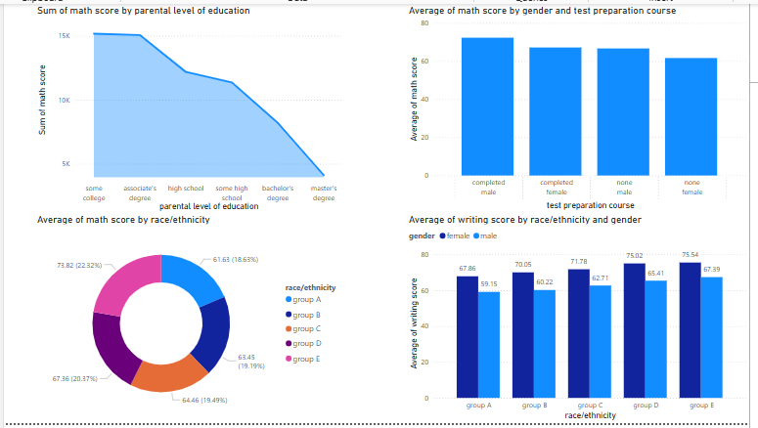

**Average writing score by race/ethnicity and gender**

**Average Reading Score by Test Preparation Course and Gender**  
I built a bar chart to compare the average reading scores based on test preparation course completion and gender. I applied the *Average* function within the visual settings to display how preparation affects reading outcomes for male and female students. This chart shows that students who completed the test preparation course have higher average reading scores than those who did not, with clear distinctions between male and female performance.

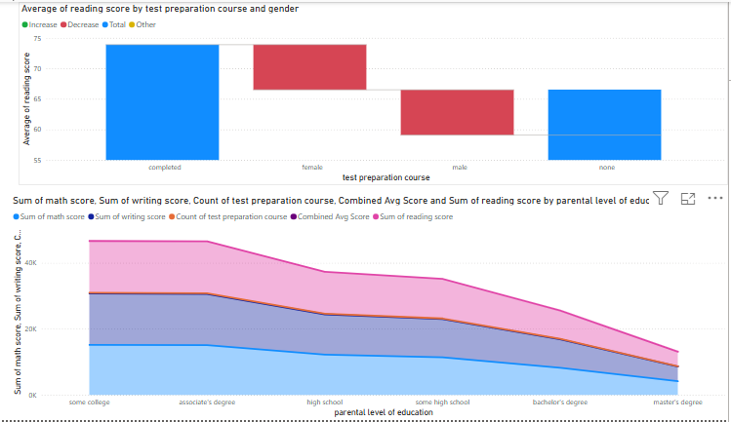

**Combined Academic Metrics by Parental Education Level**  
I created a clustered bar chart combining total math, reading, and writing scores, grouped by parental education level. I used Power BI’s default *Sum* aggregation for each subject score and combined the fields into a multi-metric visual. This chart integrates multiple academic metrics by parental education level, illustrating how total scores in math, writing, reading, and test preparation participation vary as parental education changes.